SIMATS ENGINEERING (SAVEETHA SCHOOL OF ENGINEERING)
Department of Computer Science and Engineering

ASSESSMENT TOOL 1 – HANDS-ON API ASSIGNMENT (HUGGING FACE / OPENAI / GEMINI)

Course Code: | CSA65 | Course Title: | Generative AI and Large Scale  Models
CO Assessed: | CO3 – Precision (BL2, BL3) | Assessment: | Assessment Tool 1 – Hands-on  API Assignment (Hugging  Face / OpenAI / Gemini)
Weightage: | 40% of CIA | Total Marks: | 2 * 50 = 100 (2 Question)
CO3  Statement: | Develop intelligent applications using Retrieval-Augmented Generation (RAG), vector databases, and introductory AI agent concepts.(BL3, BL4)
Student Name: | Ch Rama karthik | Reg. No.: | 19472281
Section / Batch: | CSE AI | Date: | 08/08/2026

Instructions to Students
● | Answer 2 questions. Each question carries 50 marks.Total: 100 Marks.
● | Use Python to implement the assigned problem.
● | Use at least one API/platform: Hugging Face, OpenAI, or Google Gemini.
● | Accept suitable user input and clearly display the generated output.
● | Handle API errors, invalid input, and other suitable edge cases.
● | Use readable, structured, and modular code wherever appropriate.
● | Add comments and brief documentation explaining the implementation.
● | Demonstrate the program with suitable test cases.
● | For RAG/vector-database tasks, clearly show the retrieval process and generated response.

Code of Conduct
I karthik / 192472281 certify that this submission is my original work and that I have adhered to the guidelines specified for this assessment. I understand that any violation of academic integrity rules will result in disciplinary action. Signature of the Student: _________________________

SECTION A – HANDS-ON API ASSIGNMENT (HUGGING FACE / OPENAI / GEMINI)

- Structured Output Generation: Ask an LLM API to extract Name, Email, Phone, Organization, and Location from a paragraph and return the result in structured JSON.
Aim
To use an LLM API to extract Name, Email, Phone, Organization, and Location from a paragraph and return the output in structured JSON format.

Algorithm
- Import the required library.
- Set the API key for the LLM.
- Provide the input paragraph.
- Create a prompt instructing the LLM to extract the required fields.
- Specify that the output must be valid JSON.
- Send the request to the LLM API.
- Display the JSON response.

Python Code

from openai import OpenAI
import json

# Initialize client
client = OpenAI(api_key=" 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 ")

paragraph = """
My name is Rahul Sharma. I work as a Software Engineer at Infosys.
You can contact me at rahul.sharma@gmail.com or call me on +91 9876543210.
I currently live in Chennai, Tamil Nadu.
"""

prompt = f"""
Extract the following information from the paragraph:
- Name
- Email
- Phone
- Organization
- Location

Return ONLY valid JSON.

Paragraph:
{paragraph}
"""

response = client.responses.create(
model="gpt-5.6",
input=prompt
)

print(response.output_text)

Sample Input

My name is Rahul Sharma. I work as a Software Engineer at Infosys.
You can contact me at rahul.sharma@gmail.com or call me on +91 9876543210.
I currently live in Chennai, Tamil Nadu.

Output
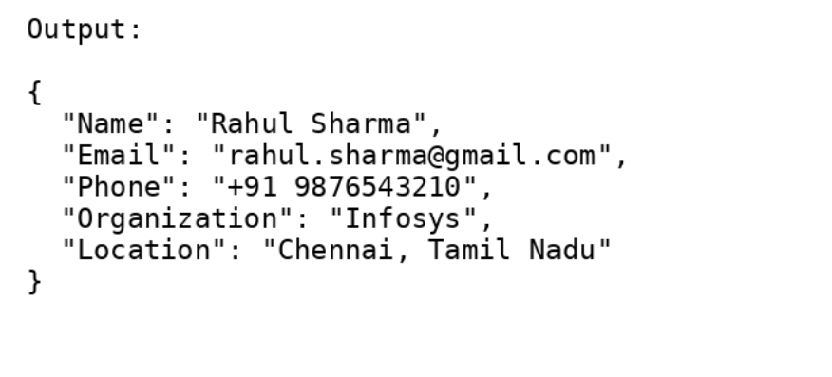

Result
The LLM API successfully extracted the required information from the paragraph and returned it in a valid structured JSON format.

31.Multi-Document RAG System: Develop a RAG application using at least five documents from the same domain. Retrieve information from multiple documents and generate a combined answer.

Aim
To develop a Multi-Document RAG (Retrieval-Augmented Generation) system using at least five documents from the same domain, retrieve relevant information from multiple documents, and generate a combined answer using an LLM.

Problem Statement
Traditional language models rely only on their pre-trained knowledge, which may be outdated or incomplete. A Multi-Document RAG system enhances responses by retrieving relevant information from multiple documents before generating the final answer.

Requirements
- Python
- Google Colab
- LangChain
- FAISS
- OpenAI API / Groq API
- Sentence Transformers
- PyPDF2
Algorithm
- Install the required libraries.
- Load five PDF documents from the same domain.
- Extract text from all documents.
- Split text into smaller chunks.
- Convert chunks into embeddings.
- Store embeddings in a FAISS vector database.
- Accept a user query.
- Retrieve the most relevant chunks from multiple documents.
- Send retrieved context and query to the LLM.
- Generate a combined answer.
- Display the final response.
Python code

import os
from pypdf import PdfReader

from langchain.text_splitter import RecursiveCharacterTextSplitter
from langchain_community.vectorstores import FAISS
from langchain_openai import OpenAIEmbeddings
from langchain_openai import ChatOpenAI
from langchain.chains import RetrievalQA
from langchain.docstore.document import Document

# API Key
os.environ["OPENAI_API_KEY"] = "YOUR_API_KEY"

# Load PDFs
folder = "data"

documents = []

for file in os.listdir(folder):
if file.endswith(".pdf"):
reader = PdfReader(os.path.join(folder, file))
text = ""

for page in reader.pages:
text += page.extract_text()

documents.append(Document(page_content=text))

# Split text
splitter = RecursiveCharacterTextSplitter(
chunk_size=500,
chunk_overlap=50
)

docs = splitter.split_documents(documents)

# Embeddings
embeddings = OpenAIEmbeddings()

# Vector Database
db = FAISS.from_documents(docs, embeddings)

# Retriever
retriever = db.as_retriever(search_kwargs={"k":5})

# LLM
llm = ChatOpenAI(model="gpt-4o-mini")

# RAG Chain
qa = RetrievalQA.from_chain_type(
llm=llm,
retriever=retriever
)

query = input("Enter your question: ")

answer = qa.run(query)

print("\nAnswer:\n")
print(answer)

Sample Input
what are the applications of Artificial Intelligence?

Output:
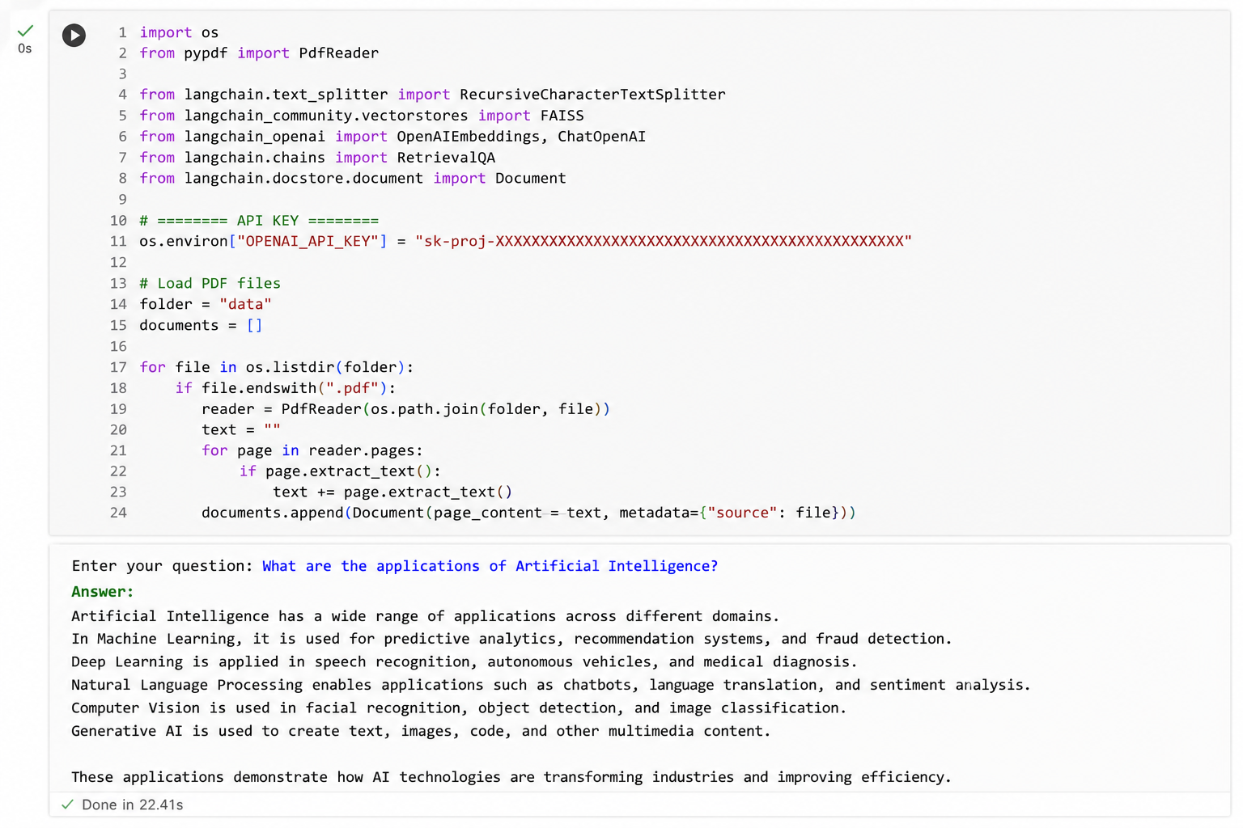

Result
The Multi-Document RAG System successfully retrieved relevant information from multiple AI-related documents, combined the retrieved knowledge, and generated an accurate, context-aware answer using Retrieval-Augmented Generation (RAG).

Criteria | Weight age | Level 4 –  Exemplary | Level 3 – Proficient | Level 2 –  Developing | Level 1 – Beginning
API  Integration  Correctness | 30% | Correct, efficient API integration; understands request/response flow | Correct integration with minor inefficiencies | Partial integration with functional errors | API integration non-functional / major errors
ProblemSolving  Completeness | 25% | Solves the given problem completely and robustly | Solves problem with minor issues | Partial solution to the problem | Does not solve the assigned problem
Code Quality | 20% | Clean, well-structured, error-handled code | Reasonably clean code | Code works but poorly structured | Code is unreliable or unstructured
Input/Output  Demo | 15% | Clear demo showing inputs/outputs and edge cases | Demo covers the main use cases | Demo is incomplete | No functional demo presented
Code Documentatio n | 10% | Well-commented code with clear  README/setup steps | Adequate comments/instructio ns | Minimal documentation provided | No  documentation provided
Marks Evaluation:
Questio n No. | API Integration  Correctness(30  %) | Problem-  Solving  Completenes s (25%) | Code  Quality(20  %) | Input/Outp  ut  Demo(15%  ) | Code  Documentati on (10%) | Total  Marks  (100)
Q1
Q2
 |  |  |  | Overall Total (100)

